**LAB 1:**

**FCFS:**

#include<stdio.h>  
  
void waitingtime(int proc[],int n,int bt[],int wt[]){  
 wt[0]=0;  
 for(int i=1;i<n;i++){  
 wt[i] = bt[i-1] + wt[i-1];  
 }  
}  
void turnaroundtime(int proc[],int n,int bt[],int wt[],int tat[]){  
 for(int i=0;i<n;i++){  
 tat[i] = bt[i] + wt[i];  
 }  
 }  
 int avgtime(int proc[], int n, int bt[]) {  
 int wt[n], tat[n], total_wt = 0, total_tat = 0;  
  
 waitingtime(proc, n, bt, wt);  
 turnaroundtime(proc, n, bt, wt, tat);  
  
 printf("Process\tBurst Time\tWaiting Time\tTurnaround Time\n");  
  
 for (int i = 0; i < n; i++) {  
 total_wt = total_wt + wt[i];  
 total_tat = total_tat + tat[i];  
 printf("%d\t\t\t%d\t\t\t%d\t\t\t%d\n", i+1, bt[i], wt[i], tat[i]);  
 }  
  
 printf("Average waiting time = %f\n", (float)total_wt / (float)n);  
 printf("Average turn around time = %f\n", (float)total_tat / (float)n);  
}  
int main() {  
 int i,n,burst[10],proc[10];  
 printf("Enter no. of processes:");  
 scanf("%d",&n);  
 for(i=0;i<n;i++){  
 printf("Enter burst time of process %d:",i+1);  
 scanf("%d",&burst[i]);  
 proc[i]=i+1;  
 }  
  
 avgtime(proc, n, burst);  
  
 return 0;  
}

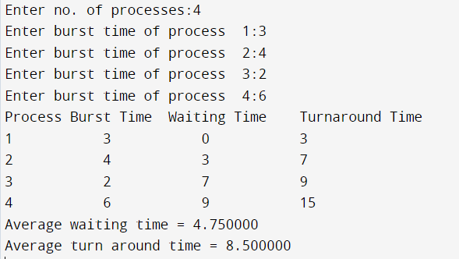

**SJF:**

#include<stdio.h>  
  
void waitingtime(int proc[],int n,int bt[],int wt[]){  
 wt[0]=0;  
 for(int i=1;i<n;i++){  
 wt[i] = bt[i-1] + wt[i-1];  
 }  
}  
void turnaroundtime(int proc[],int n,int bt[],int wt[],int tat[]){  
 for(int i=0;i<n;i++){  
 tat[i] = bt[i] + wt[i];  
 }  
 }  
 int avgtime(int proc[], int n, int bt[]) {  
 int wt[n], tat[n], total_wt = 0, total_tat = 0;  
  
 waitingtime(proc, n, bt, wt);  
 turnaroundtime(proc, n, bt, wt, tat);  
  
 printf("Process\tBurst Time\tWaiting Time\tTurnaround Time\n");  
  
 for (int i = 0; i < n; i++) {  
 total_wt = total_wt + wt[i];  
 total_tat = total_tat + tat[i];  
 printf("%d\t\t\t%d\t\t\t%d\t\t\t%d\n", i+1, bt[i], wt[i], tat[i]);  
 }  
  
 printf("Average waiting time = %f\n", (float)total_wt / (float)n);  
 printf("Average turn around time = %f\n", (float)total_tat / (float)n);  
}  
int main() {  
 int j,temp2,temp,i,n,burst[10],proc[10];  
 printf("Enter no. of processes:");  
 scanf("%d",&n);  
 for(i=0;i<n;i++){  
 printf("Enter burst time of process %d:",i+1);  
 scanf("%d",&burst[i]);  
 proc[i]=i+1;  
 }  
 for(i=0;i<n;i++){  
 for(j=i+1;j<n;j++){  
 if(burst[i]>burst[j]){  
 temp=burst[i];  
 burst[i]=burst[j];  
 burst[j]=temp;  
 temp2=proc[i];  
 proc[i]=proc[j];  
 proc[j]=temp2;  
 }  
 }  
 }  
  
 avgtime(proc, n, burst);  
  
 return 0;

}

